**To properly complete this course:**

1. Adjust your Flash Security Settings, as detailed below. ***Note: This only has to be done the first time you access the course on a given computer.***
2. Open the **start.html** file using **Internet Explorer** or **Firefox**.
3. When prompted, **enter your first and last name** exactly as you wish them to appear on your certificate of completion.
4. Review the system requirements and instruction screens, and then select **Scenario 1** to begin.

***Note: If you get stuck loading Scenario 1, review the instructions below on adjusting your Flash Security Settings.***

**Adjusting Flash Security Settings**

**In order to properly view this course, you must adjust your Flash player security settings.**

1. First, you need to open the Flash Player Settings Manager Window.
   1. Go to the “Start” menu and open the “Control Panel”.
   2. Locate the Flash Player icon and double-click to open it (it may take a minute for the Flash Player icon to load).

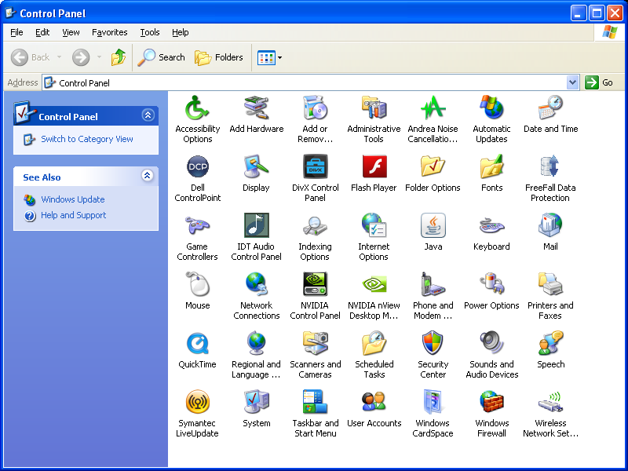

1. Select the “Advanced” tab in the Flash Player Settings Manager Window.

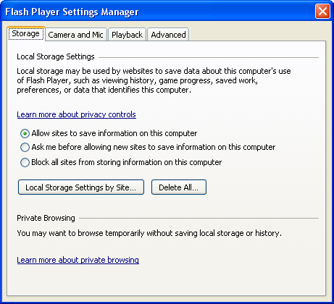

1. Click the “Trusted Location Settings…” button at the bottom of the screen.

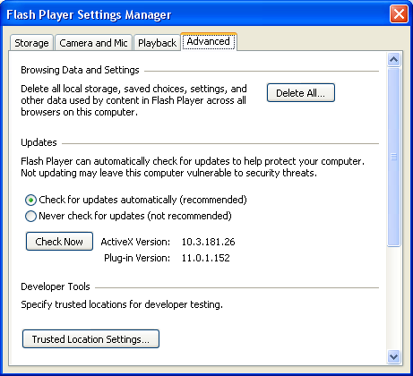

1. Click the “Add…” button.

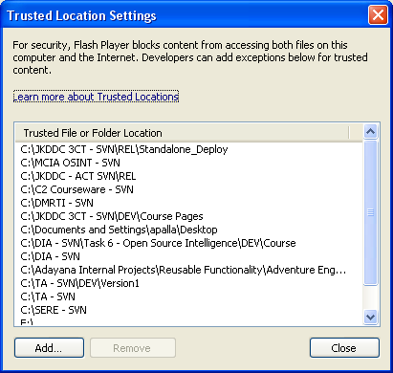

1. Click the “Add Folder…” button.

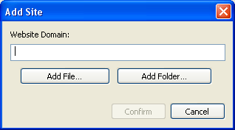

1. Navigate to your CD/DVD drive, or the folder where the files are stored on your machine. Highlight the drive or folder and click “OK”.

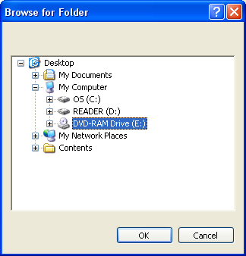

1. The path to the drive or folder should now be displayed in the Website Domain box. Click “Confirm”.

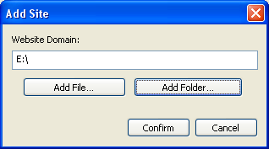

1. Click close on the Trusted Location Settings Window and close the Flash Player Security Settings Window.
2. Exit your browser and re-start the course.